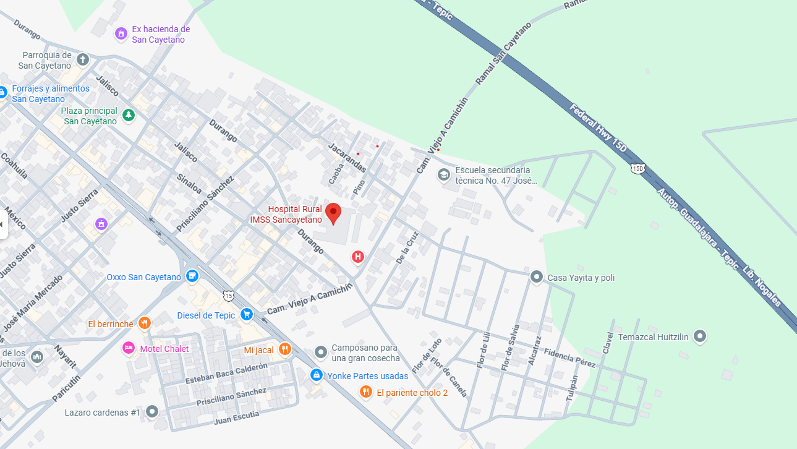
21.450203742909473, -104.81234952798496

